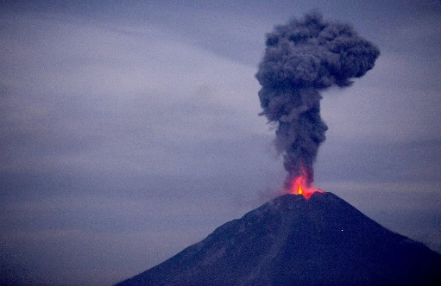Volcano Teaching Assignment

You and your partner are tasked with teaching a group of students about Volcanoes. This will count towards both process grades and your product grades. Your group will need to create:

|  |  |
| --- | --- |
| Process (50 Points) | Product (50 Points) |
| Reading Assignment (10 pts) | 10 REM and 5 UND Questions (10 pts) |
| Thinking Notes (10 pts) |  |
| Video & Questions (10 pts) | Final Presentation (Lecture) (40 pts) |
| In-class Activity (10 pts) |  |
| Draft Presentation &  Guided Notes / Graphic Org (10 pts) |  |

# Process Grades

Each of the following items must be unique to your group. For example, two groups cannot use the same video or in-class activity.

* Reading Assignment: Identify a reading assignment that gives the student knowledge they need about the characteristics of all Volcano types.
* Thinking Notes: Create a Thinking Notes “exemplar” demonstrating what the students should have done if they did the marked the reading correctly.
* Find a video (> 8 minutes) about Volcano characteristics and create five (5) questions from the video for students to answer (to keep them interested!)
* In-class Activity. Find an Activity for the students to do after the presentation to reinforce some or all of the Volcano vocabulary and concept presented during the PowerPoint presentation
  + Note: NOT a Word Search unless there is significantly more involved.
* Guided Notes or a Graphic Organizer: Based on a draft of your PowerPoint presentation, create guided notes or a graphic organizer that guides the student to write down the most important information from the lecture.

# Product Grades (50 Points)

* 10 REM and 5 UND Questions (10 points): In MS Forms, write 10 Remember (multiple-choice) questions and 5 Understand (short answer) questions with the correct answers marked as an Answer Key.
* Final Presentation / Lecture (40 Points). As a group, present your final PowerPoint Presentation. Use the guidelines listed in the Presentation Contents section below. The grading will be broken down as follows:

|  |  |  |
| --- | --- | --- |
| Lecture Participation | 5 Points |  |
| Ability to Answer Questions | 5 Points |  |
| Contents: Section 1 | 10 Points |  |
| Contents: Section 2 | 10 Points |  |
| Contents: Section 3 | 10 Points |  |

# Presentation Contents

Your presentation must include:

1. 3 main types of volcanos
   1. Shield
   2. Composite/Strato
   3. Cinder cone
   4. Give examples of active volcanos for each and some potentially active volcanos (hint: Look up Yellowstone National Park)
2. Description of each type to include
   1. Look/shape
   2. Silica Content
   3. What causes it (Hint: think about plate tectonics and layers of Earth)
   4. Relative energy released when erupting
3. Describe properties of Magma and how they relate to one another
   1. Describe different types (names) of Magma
   2. Silica Content
   3. Viscosity
   4. Melting Temperature
   5. Tendency to form Lava